Uniform Circular Motion

PHYS 211L – H02

Tuesday 10:05am – 12:05pm

Abstract

In this lab, we investigated uniform circular motion, paying close attention to the relationship between force and acceleration. Using this relationship, we determined the mass of an object experiencing uniform circular motion. We used the period the object’s motion and also measured how much force is required to position the object at the radius of the circle it traveled while in motion. Using this information and comparing it to our measured mass of 0.35kg, we found that the mass of a bob undergoing uniform circular motion is (0.3502 ± 0.02) kg.

Introduction

The idea of uniform circular motion was initially formed in a basic and qualitative version by the minds if Galileo1 and Descartes. It wasn’t until the 17th century when Christiaan Huygens was able to solve the problem and derive a method of quantizing uniform circular motion. His studies were fundamental in discovering the magnitude of gravitational forces such as those between the Sun and Earth. However, it was not in the form that we know today as $a=\frac{v^{2}}{r}$ until Isaac Newton modified it and improved upon the less refined version.

Using the information derived by these physicists, we are able to conduct and experiment in which we measure the period, radius of rotation, and force to calculate the mass of an object undergoing uniform circular motion. We then let the object remain stationary as we attached mass to it until it was correctly positioned above our chosen radius. As a result, when applying Newton’s 2nd Law to our object, we get $\frac{Mv^{2}}{r}=mg$, where $m$ is the mass attached to our object, $M$ is the mass of the object itself, $\frac{v^{2}}{r}$ is the acceleration the object experiences while in motion, and $g$ is the acceleration due to gravity, which for our experiment is taken to be 9.81 m/s/s. This experiment is applicable in a system where an object moves with uniform circular motion defined by constant speed.

Procedure

In this lab, we used the following materials: the circular motion apparatus, a set of weights and weight holders, a stopwatch, a meter stick, and a laboratory balance.

First, we measured the mass of the bob attached to the circular motion apparatus using the laboratory balance. We then measured the distance from the center of the apparatus to the radius point, making sure to account for the 3.175 centimeters of the vertical shaft. At this point in the experiment, we chose a radius point and spun the circular motion apparatus until the bob passed directly over the chosen location. While the system was spinning, we used a stopwatch to measure the time it took for the apparatus to complete 15 revolutions, using the recordings to calculate the period.

Next, we used the pulley attached to the circular motion apparatus attached to a weight holder. We used this set up to determine how much force is needed to achieve the same change in distance of the bob as when it was rotating. This was done by consistently adding more and more weight in small increments until the spring was extended enough for the bob to reach the chosen radius point.

Here is a diagram for each of our setups:

Setup 2

Setup 1

BobC

Pulley

Spring

Weight holder with weights

Circular motion apparatus

Radius measurements

Results/Analysis/Physics

We measured the mass of the bob to be 0.35kg. By substituting $v=rω$ into the equation $\frac{Mv^{2}}{r}=mg$ and solving for $M$, we find that $M=mg/rω^{2}$, where $mg$ is the force exerted on the bob by the suspended mass required to correctly position the bob at our chosen radius, and $rω^{2}$ is the bob’s frequency of rotation. Calculating these quantities for each trial and graphing them results in a line where the slope is the mass of the bob.

All Raw and Calculated Data

|  |  |  |  |  |  |  |  |  |
| --- | --- | --- | --- | --- | --- | --- | --- | --- |
| Radius when rotating (m) | Uncertainty in radius (m) | Time for 15 rotations (s) | Period of the bob (rev/s) | Mass needed to position the bob at radius (kg) | Uncertainty in the mass required to position the bob (kg) | Force exerted on the bob by the suspended mass (N) | Frequency of Rotation (m/s/s) | Percent uncertainty in the mass of the bob |
| 0.18 | 0.036 | 8.86 | 0.5907 | 0.860 | 0.15 | 8.438 | 20.37 | 0.131 |
| 0.22 | 0.036 | 7.25 | 0.4833 | 1.320 | 0.25 | 12.95 | 37.18 | 0.124 |
| 0.14 | 0.036 | 12.83 | 0.8553 | 0.255 | 0.05 | 2.502 | 7.555 | 0.159 |
| 0.16 | 0.036 | 9.75 | 0.65 | 0.555 | 0.10 | 5.446 | 14.95 | 0.142 |

Free Body Diagram of the Bob While it’s Undergoing Uniform Circular Motion

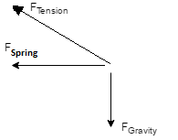

Free Body Diagram of the Bob While it’s not in Motion and the Weight Hanger is Attached

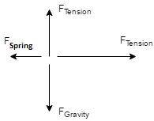

Force Acting on the Bob (N) vs. Frequency of Rotation (m/s/s)

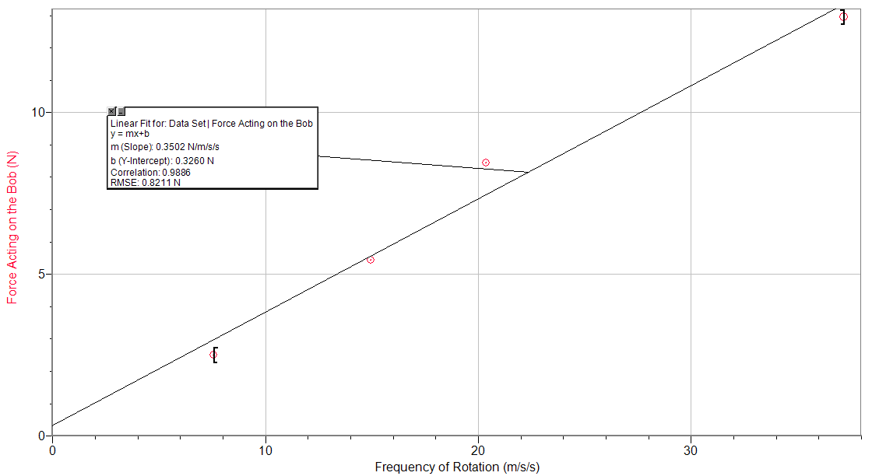

Conclusion

From this lab we were able to experience first-hand the relationship between mass, velocity, radius, and force in a uniform circular motion system. Because we were able to measure each individual quantity separately, i.e. the mass with a balance, the velocity using the period, radius with a meter stick, and force with a pulley, we were able to test the relationship. Knowing each individual component of a formula allows us to use it and test the accuracy of the calculated value versus the actual value. Thus, knowing all but one of the variables in $\frac{Mv^{2}}{r}=mg$ allows us to solve for the unknown. Knowing $v=rω$ and using substitution, we are able to derive the formula $M=mg/rω^{2}$. This allows us to plot the Force, $mg$, against $rω^{2}$. The slope of this graph will give us the mass of the bob in the experiment’s system.

Most uncertainties in this experiment are the result of friction. The main culprit of this friction is the motion of the bob as it moves through the air. The air resistance in the room the experiment is performed in will significantly slow the circular motion apparatus’ spinning the longer it remains in motion. There is also friction present in between the string and the pulley during the measurement of force mg on the spring. This would alter the calculated results of our experiment by some value. Additionally, the method used to determine the spinning radius of the bob is to “eyeball it” which leads to very inaccurate results as a human being is trying to determine the location of a spinning object at one instant. Also fuck the lab instructions and us for fucking up so astronomically.

[*Second Universal Question*] The idea of uniform circular motion is present in many aspects of life. For example, at the fair ride where you are placed in a spinning room that presses you up against the wall, all of the components of the experiment are present. Instead of a bob, *you* are having a force acted upon you equal to your mass times your velocity squared divided by the radius of the machine. Another example that unknowingly affects us at every instant is the motion of the planets. They experience a force of gravity that causes them to remain in motion around the sun at a certain velocity determined by the same relationship.

Lab Questions and Calculations

1. Uniform circular motion is the motion of an object in a circle at a constant speed. Our actual procedure did not follow this definition due to air resistance.

4. The force acting on the bob divided by the frequency of rotation gives the theoretical mass of the bob. In terms of the graph, the slope of the line is the theoretical mass of the bob.

5. Using the graph, we get a value that does agree with our measurement within uncertainty. The mass from the slope of the graph is extremely close to our measured mass of the bob, with a percent error of approximately 0.06%.

6. The bob is accelerating towards the vertical shaft that it is attached to, which is how the bob’s path of motion is a circle.

References

1. J., Am. "Circular Motion." 2000 American Association of Physics Teachers. 68.7 (2000): 637-39. 2000 American Association of Physics Teachers. Web. 17 Oct. 2016. <http://henry.pha.jhu.edu/henryDir/pubsPDFDir/circularMotion.pdf>.